Section F. The reward function
The generative capabilities of Nexerra^{R1} do not extend to the efficient discrimination of useful linkers – i.e., linkers with favorable properties – against linkers that are sub-optimal. Even with the addition of the flow model, we are at best able to favor linker sampling against certain target properties (for instance, linker length). For most applications, we need to optimize several, often competing properties. Such complex design criteria are not compatible with the working principles of Nexerra^{R1}. We thus rely on reward functions that score linkers based on their utility for the application of interest. In this context, reward functions offer several advantages: (i) they are modular, i.e., they can be easily formulated for an application of interest to screen for desirable linkers; (ii) they are computationally cheap and do not require any additional model training; and (iii) they can span arbitrary complexity. On the downside, these functions rely on several simplifications and assumptions, and on the whole are tough to generalize. Functions formulated for a system of interest, may not necessarily work well for other systems. Nonetheless, the flexibility on offer enables access to vast design spaces that in principle, span multiple application landscapes.
Here, as case studies, we formulate two reward functions targeting: (i) gas storage and (ii) biocompatibility. Before proceeding to the formulation of these functions, we preface the discussion by clarifying that these functions operate completely at the linker-level and do not explicitly account for metal-node and topology effects, host-guest interactions, and framework flexibility. These characteristics undoubtedly play critical roles in the overall performance, and can be evaluated using geometric analysis and molecular simulations on assembled frameworks. The goal here is to develop computationally lightweight structural filters to bias generation towards desirable chemotypes.

F.1. Gas storage. In the design of adsorbents for gas storage (e.g., H₂, CH₄), the deliverable capacity is a critical design parameter. Here, the gravimetric uptake – mass of adsorbate taken up per unit mass of adsorbent – and the volumetric uptake – mass of adsorbate taken up per unit volume of adsorbent – are two equally important, yet competing metrics. Design strategies need to focus on concurrently optimizing both objectives. At the linker level, several structural characteristics influence framework-level gas storage capabilities: (i) anchor-to-anchor span, which modulates the node-node separation and the pore size; (ii) molecular weight, which controls framework density; (iii) rigidity, which impacts disorder and framework collapse; and (iv) linker symmetry, which impacts the packing efficiency.
Starting with gravimetric storage, the capacity benefits by maximizing accessible void volume per unit mass. To approximate this at the linker-level, we define a mass-normalized span descriptor as:
$$d_{mass-norm-span}=\frac{d_{anchor-anchor}}{MW}$$
Where, $d_{anchor-anchor}$ is the maximum anchor – anchor distance and $MW$ is the molecular weight of the linker (excluding anchors). $d_{mass-norm-span}$ serves as a proxy for structural expansion per unit mass. This proxy – which is intended as a purely relative descriptor – biases generation towards longer, lightweight linkers. At the same time, such linkers tend to exhibit a high-degree of flexibility, which makes ultraporous frameworks susceptible to potential pore collapse. We therefore introduce a second descriptor $d_{rigidity}$ that penalizes flexible linkers that may promote framework collapse. The rigidity proxy is defined as follows:
$$d_{rigidity}=0.5×RBC+0.5×N_{C_{sp^{3}}}$$
Where, $RBC$ is the fraction of the rotatable bonds in the linker and $N_{C_{sp^{3}}}$is the fraction of $sp^{3}$ Carbons in the linker. Put together, the gravimetric reward ($R_{grav}$) is defined as follows:
$$R_{grav}=α_{1}D\left(d_{anchor-anchor}\right)+α_{2}D\left(d_{rigidity}\right)+α_{3}D\left(d_{mass-norm-span}\right)$$
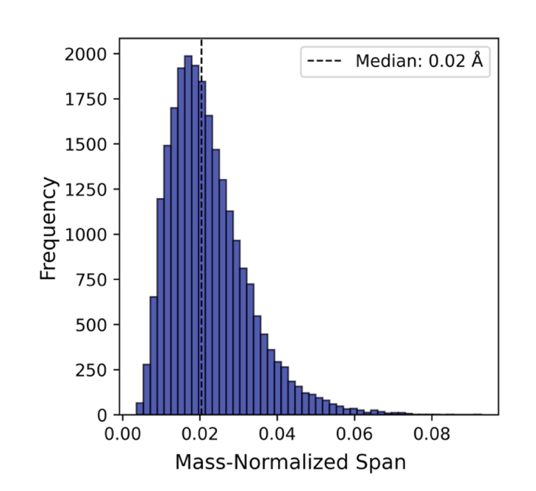
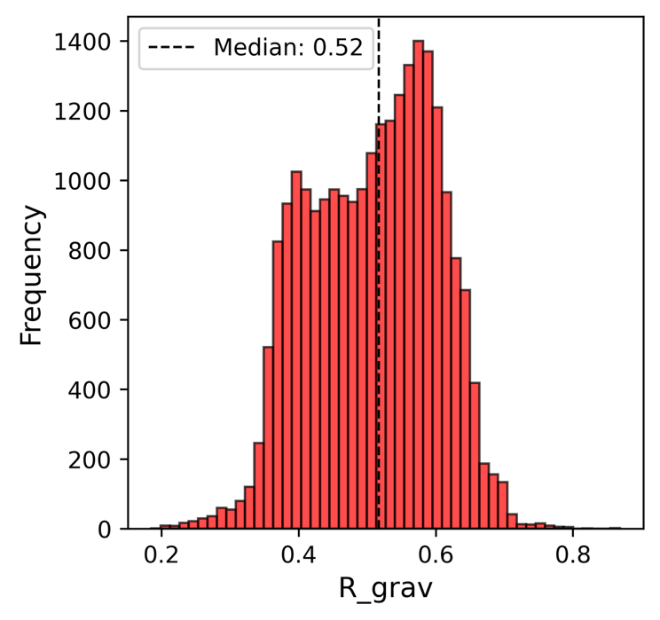
Where, $D$ denotes bounded desirability functions that prevent extreme values from distorting the reward scores while enabling smoother interpolations; $α_{1}, α_{2}, α_{3}$ denote the relative weights assigned to each term. In the case of the mass-normalized span descriptor, $D$ is an increasing sigmoidal function centered around the 75th percentile of the distribution from the sampled training set (Figure F1). Due to the strong regularization effect of this descriptor that penalizes heavy linkers, it is assigned a lower weightage of 0.2. For the flexibility descriptor, $D$ is a decreasing sigmoidal function centered around 0.5, with a width of 0.2. For the span descriptor, $D$ is an increasing sigmoidal function centered around 16 Å, with a width of 4 Å. Overall, $R_{grav}$ encodes structural priors that support lightweight, long-span, shape-persistent linkers. Figure F2 shows the $R_{grav}$ distribution of linkers from the training set (n = 25000). The distribution has a median reward of 0.52 (p75 = 0.58, p25 = 0.43). Crucially, the distribution is not skewed to either extreme confirming that the rewards are not saturated; instead, the rewards span a healthy range of (0.2, 0.8). The absence of sharp cutoffs or collapsed modes indicates that the reward landscape is well-conditioned and preserves meaningful variance across chemically diverse linkers. The function should ensure that structural modifications produced graded changes in the reward – consistent with flow-based optimization.
Figure F1. Distribution of the mass-normalized span for molecules from the training set (n = 25000). Median = 0.02 Å mol g⁻¹; p75 = 0.03 Å mol g⁻¹ and p25 = 0.01 Å mol g⁻¹. The increasing sigmoidal desirability function is centred around p75, with a width of 0.5 x (p75 – p25) to favour linkers with favourable mass-normalized spans.

Figure F2. Distribution of the gravimetric reward score ($R_{grav}$) for molecules from the training set (n = 25000). Median = 0.52; p75 = 0.58 and p25 = 0.43. Notably, the distribution is not skewed towards either extreme bound – which would have been indicative of collapse. The distribution spans almost the entire range and we also observe a smooth gradient towards higher scores, suggesting that a non-trivial fraction of the training linkers achieve high scores [$α_{1}$= $α_{2}$= 0.4; $α_{2}$= 0.2].

Figure F3 shows the $R_{grav}$ scores computed for linkers corresponding to some of the top-performing MOFs for gravimetric CH₄ storage. The scores assigned to each linker roughly correspond to the observed CH₄ storage trends. Notably, the linker of CU-6 – a MOF recently reported by some of us – which has the highest gravimetric CH₄ storage capacity to date shows the highest relative $R_{grav}$ score. We however stress that there are several aspects relating to metal-node effects, topology and volumetric packing that are not captured here; this remains a computationally-efficient proxy for discriminating linkers.
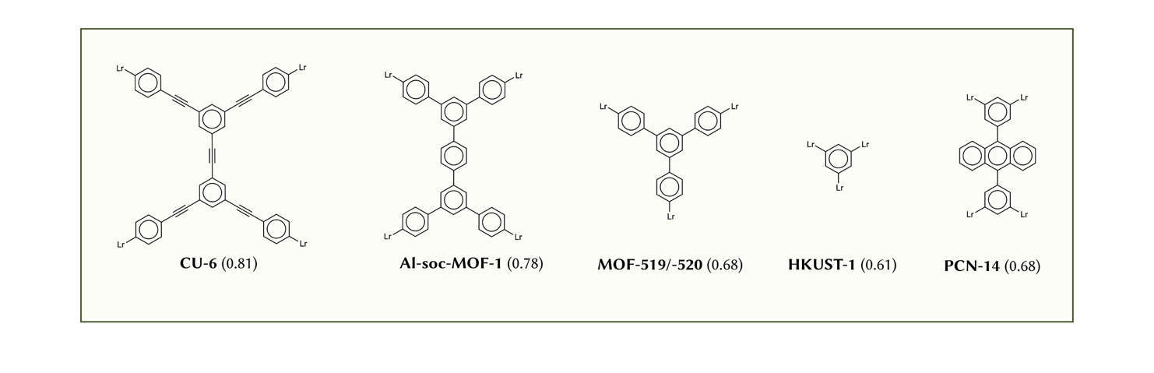
Figure F3. $R_{grav}$ scores for linkers belong to top-performing MOFs for gravimetric CH₄ storage. There ranking of benchmark linkers is broadly consistent with reported trends. However, for a complete assessment, it is crucial to account for metal-node effects, topology and volumetric packing. As an illustrate example, while MOF-519 and MOF-520 share the same linker, they differ in coordination environments that in-turn have a significant impact on storage capacities.

Moving to volumetric storage, the goal is to balance porosity with the framework density. Excessively long, lightweight linkers which favor gravimetric storage, will lower the volumetric capacity due to reduced packing density. Accordingly, a balanced reward function needs to account for: (i) anchor – anchor span; (ii) rigidity; (iii) symmetry of the linker (or a proxy-thereof); and (iv) intermediate molecular weights that avoid excessively heavy (reduces gravimetric capacity) and light (reduces volumetric capacity) linkers. The balanced gas storage reward ($R_{gas}$) is defined as follows:
$$R_{gas}=β_{1}D\left(d_{anchor-anchor}\right)+β_{2}D\left(d_{rigidity}\right)+β_{3}D\left(d_{symmetry}\right)+β_{4}D\left(d_{MW}\right)$$
Where $d_{symmetry}$ is a measure of similarity of the chemical environment around each anchor using Morgan fingerprints (a proxy for linker symmetry) and $d_{MW}$ is the molecular weight of the linker passed through a Gaussian desirability function that penalizes extremely heavy and lightweight linker while rewarding linkers with intermediate molecular weights (Figure F4). Each component is bounded between $\left[0.05, 0.95\right]$ and the parameters $β_{1}-β_{4}$ are tunable. $R_{gas}$ is similarly bounded between $\left[0.05, 0.95\right]$, with higher values suggesting an increased applicability for gas storage. We note here that several parameters (especially the Gaussian desirability function) may need to be tuned to the system of interest.
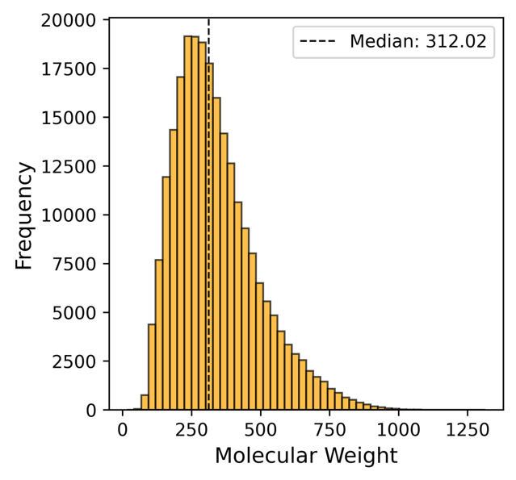
Figure F4. Distribution of the molecular weight of molecules from the training dataset (n = 250000). The distribution follows an expected trend with a mode around 250 g mol⁻¹, median of 312 g mol⁻¹ and a long tail that extends past 1250 g mol⁻¹. Ideal linkers for gas storage should adopt intermediate molecular weights – i.e., not too light to favor low framework densities yet not too heavy to favor high densities. We thus define a Gaussian desirability function (centered around 320 g/mol) with a width of 140 g/mol that rewards these intermediate values while penalizing extremes.
The parameters $β_{1}-β_{4}$ were empirically optimized against known linkers belonging to high-performing MOFs, with weights selected to preserve qualitative ranking of linkers corresponding to benchmark MOFs. At values of $β_{1}$ = 0.2; $β_{2}$ = 0.2; $β_{3}$ = 0.4 and $β_{4}$ = 0.2, the reward score trends were found to reasonably correlate to experimental data. Figure F5 (bottom) shows the distribution of $R_{gas}$ values using these parameters when evaluated on 25000 molecules from the training dataset. The distribution is broad (with a median at 0.43) and similar to the $R_{grav}$ distribution, does not saturate at either extreme. There is a weak bimodal character, with a secondary shoulder at higher values, suggesting a partitioning of the linker space into two regimes. The larger class is geometrically sub-optimal (Figure F5 (top)), while the smaller class is primarily driven by symmetry and rigidity components of the score. This is by design, considering that reticular assembly of frameworks of interest favor linkers with symmetric anchor environments and lower conformational flexibility yet having a reasonable span.
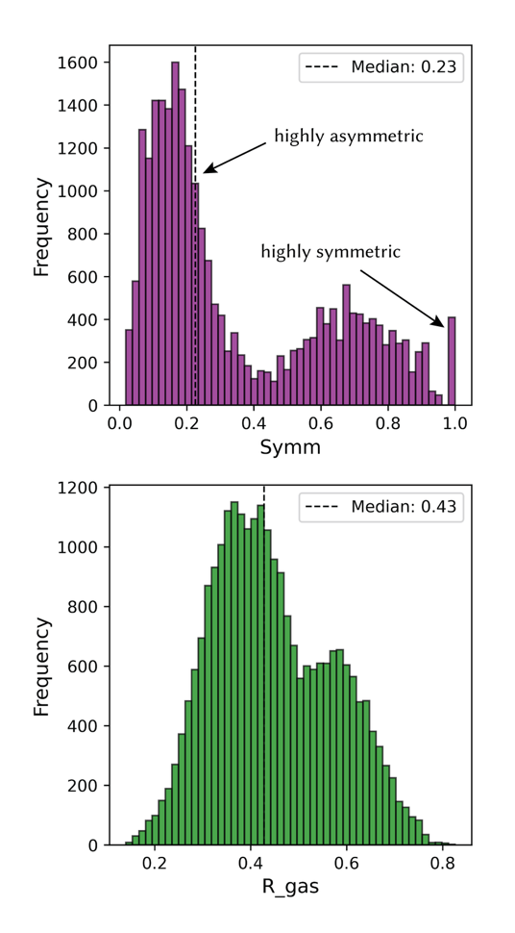
Figure F5. Distribution of the $d_{symmetry}$ (top) and $R_{gas}$ scores (bottom) of molecules from the training dataset (n = 25000). $d_{symmetry}$ has a strong bimodal distribution suggesting the partitioning of the linker space into two classes: linkers with sub-optimal symmetry and linkers with optimal symmetry. Only 1.6% of the linkers attain the maximum $d_{symmetry}$. For $R_{gas}$, the distribution is broad (median = 0.43) with a weak bimodal character. Neither extreme is saturated – confirming that there is no collapse. The weak bimodal character stems from the partitioning of the linker space described above. Here, the smaller class indicates more favorable symmetry and rigidity yet having a reasonable span and molecular weight.

Figure F6 shows the $R_{gas}$ scores computed for linkers corresponding to some of the top-performing MOFs for gravimetric CH₄ storage. Again, the scores assigned to each linker correlate well with the observed trends. In this instance, the linker of Al-soc-MOF-1 shows a higher relative $R_{gas}$ score compared to the linker of CU-6. The linker in PCN-14 shows the highest relative score; while the MOF itself is not the best performing, its performance is competitive nonetheless. Yet again, we stress that there are several aspects not captured here; we remind the reader that this remains a computationally-efficient proxy for discriminating linkers.
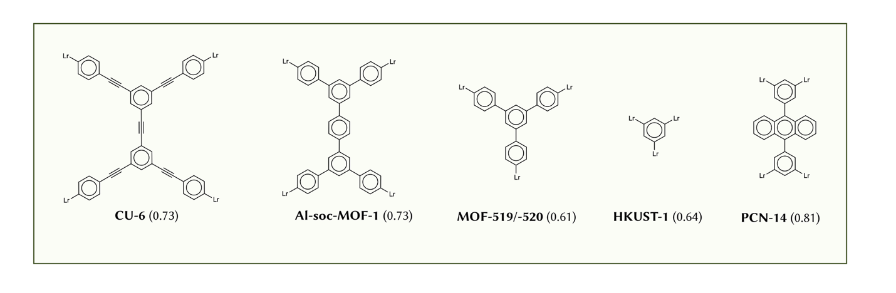
Figure F6. $R_{gas}$ scores for linkers belong to top-performing MOFs for CH₄ storage. There is a reasonable correlation between the score assigned to the linker and the reported gravimetric and volumetric storage capacities of the MOF. However, for a complete assessment, it is crucial to account for metal-node effects, topology and volumetric packing.

F.2. Biocompatibility.
For drug-delivery applications, the goal is not only to identify synthetically plausible linkers, but to prioritize chemotypes that remain safe, soluble, and functionally effective after framework assembly. Consistent with the gas-storage analysis above, we preserve the geometric approach of linker-level screening while introducing safety, performance and compatibility controls that are directly relevant to biomedical deployment.
The logic of this reward is modular, including (i) Safety terms penalizing metals and linker chemistries or fragments associated with high acute-toxicity risk (ii) Performance emphasising linker span, solubility and accessible porosity properties for loading space, which include pore-limiting diameter (PLD) and accessible surface area (ASA) or SMILES-derived approximations if unavailable. (iii) Benign-linker terms suppressing strongly interacting or reactive motifs that can trap, degrade, or perturb therapeutic cargo, (iv) Stability prioritising candidates less likely to trigger burst release, premature linker failure, or charge-driven instability under physiological conditions, finally (v) Penalty element penalising linkers with known toxicity warnings and extreme charge states.
The biocompatibility objective is defined as:
$$R_{bio} = w_{S}S+w_{P}P+w_{B}B+w_{T}T-P$$
where S, P, B, and T denote safety, performance, benign-linker behaviour, and stability sub-scores, respectively, and P is an explicit penalty for warnings and extreme charge states. All scores and components are ranged between [0,1].
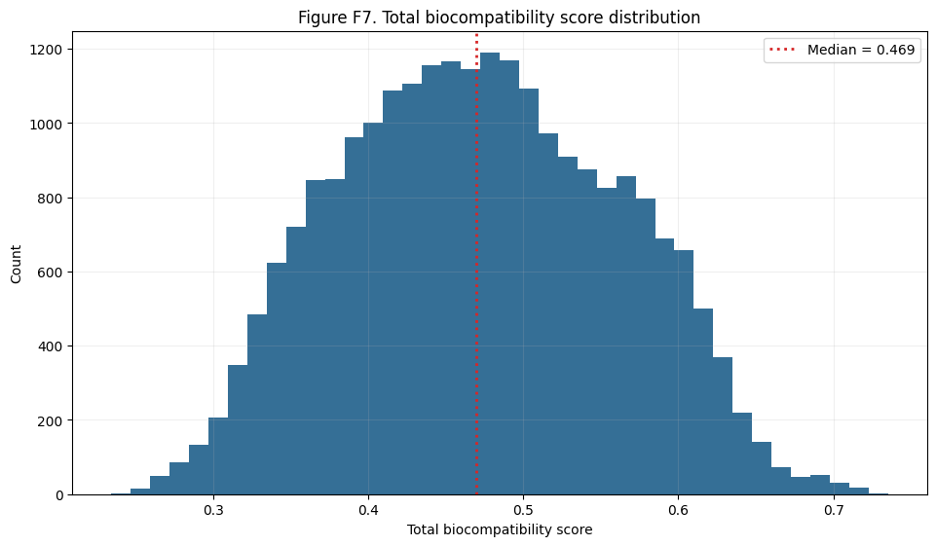
Figure F7 shows the distribution of the biocompatibility scores across the training set (n=25,000) of linkers, of which 93.76% produced valid scores after invalid SMILES cleaning/parsing. The total score distribution remains broad (min=0.288, max=0.793, median=0.469), indicating non-collapsed ranking capacity for optimization loops.
The safety block combines: (i) metal-node safety from curated LD50-based priors reported by Menon (2025), (ii) toxicity-space proximity derived from acute-toxicity chemistry, and (iii) formal-charge safety.
$$S_{safety}=α_{m}M_{tox.metal}+ α_{t}T_{tox.space}+α_{q}Q_{charge}$$
The toxicity-space term is built from descriptor and fingerprint neighbourhoods obtained from LD50 readouts for 35,300 compounds in TOXRIC Database (Wu, 2022). 55-feature standardized numeric manifold (RDKit descriptors) and ECFP4 fingerprint manifold (2048 bits) were blended by learned block weights: numeric 0.62, fingerprint 0.38. Toxicity severity was weighted across GHS classes (Class 1 as the most severe to Class 5 associated with least toxic compounds) so that proximity (k-NN) to highly toxic regions is penalized more strongly.
Toxicity-space was validated using several MOF that were reported to have been tested for drug delivery applications, including PCN-222 (Tetrakis (4-carboxyphenyl) porphyrin (TCPP) linker), UiO-66 (terephthalic acid linker), NU-1000 (Pyrene tetrabenzoic acid) and ZIF-8 (2-imidazoline, featuring known LD50 oral rat toxicity at ~ 1,400 mg/kg).
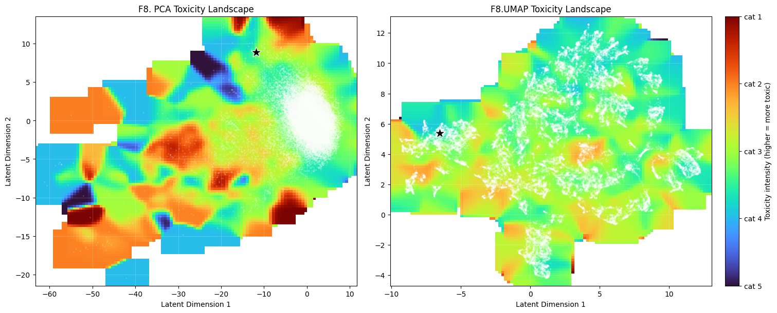
Figure F8: Illustrates 2-dimensional PCA and UMAP shape of the toxicity-space and positioning of TCPP linker, which is placed in close proximity to non-toxic domain, as expected, validating the latent structure of the toxicity space.
The performance block combines linker length, solubility, and surface/loading proxies.
$$P_{performance}=b_{L}L_{length}+ b_{B}B_{solubility}+b_{O}O_{loaing}$$
Linker length is estimated from anchor-to-anchor separation and heavy-atom span; solubility is encoded using LogS together with a bounded LogP window; surface/loading uses ASA and PLD when available, with deterministic linker-level proxies otherwise. Pore accessibility and packing constraints remain fundamental for biocompatibility applications as well.
The benign-linker block combines formal-charge moderation, a payload-interaction window (LogP and TPSA), and structural alert burden (PAINS/BRENK/NIH).
$$B_{benign}=c_{Q}Q_{charge}+ c_{I}I_{interaction}+c_{B}B_{burden}$$
The function should penalise excessively sticky or reactive linker environments that increase side-effects, off-target adsorption, or irreversible payload-framework interactions. We note also that charge contributes to both safety and benign terms by design: safety captures acute electrostatic risk while benign score captures the payload interaction fit.
Structural burden is estimating by calculating normalised count of reported warning matches for the fragments of the generated structure in either a) PAINS (PanAsseyInteference) b) BRENK (reactive, toxic, or unstable fragments) or c) NIH (problematic functional groups based on NIH medicinal chemistry guidelines).
The stability block integrates metal stability, linker rigidity/symmetry, solubility-mediated dispersion behaviour, and charge-release stability.
$$T_{stability}=d_{M}M_{metal.stab}+ d_{K}K_{linker.stab}+d_{S}S_{solubility}+d_{R}R_{release}$$
Solubility is also recognised as important predictor of desirable bioavailable MOF delivery nanoparticles. Metal stability and safety are obtained for the curated dataset in Menon (2024), while the stability of the linker is determined based on rigidity and symmetry similar to the reward function for gas storage in F1 above.
Together, these terms bias toward candidates that support controlled exposure rather than abrupt release or rapid framework deterioration.
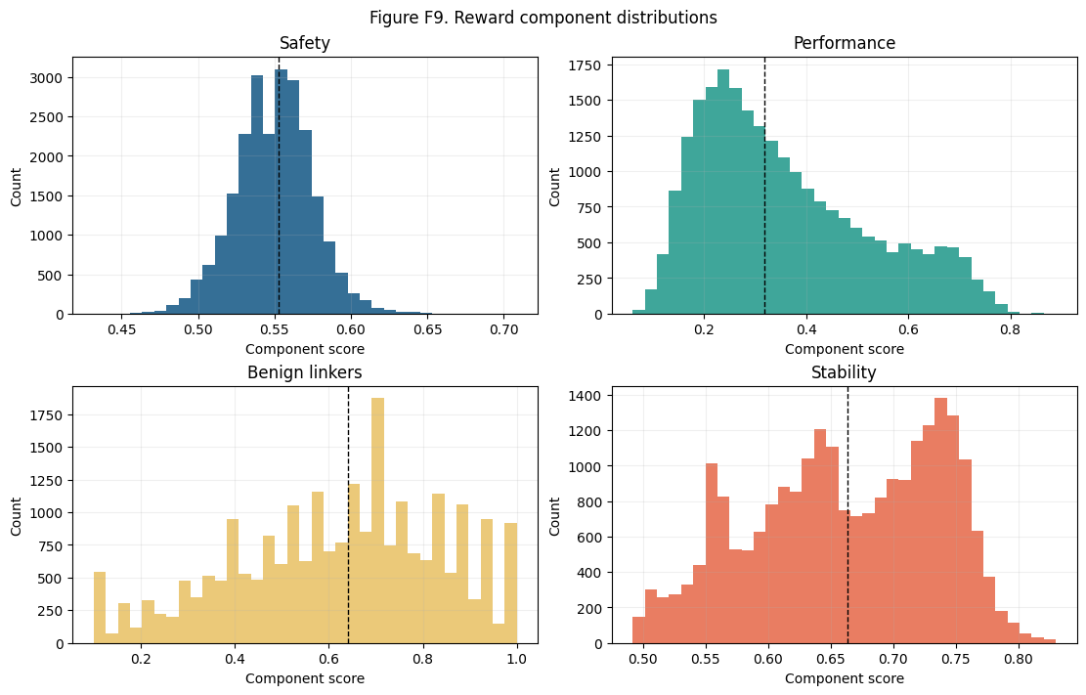
Figure F9 is showing the distribution of component scores, reporting means Safety: 0.553, Performance: 0.319, Benign linkers: 0.640 and Stability: 0.664.
During method development, Bayesian optimisation was used to tune component and subcomponent weights under constrained known validation linker samples. The design objective combined toxicity-aware ranking constraints (to suppress high scores in severe toxicity classes), smooth score spread across viable chemotypes, and robustness across repeated sampled subsets. Final production weights were selected from the stable region identified across these runs and then fixed to preserve deterministic scoring as w_{S}=0.15, w_{P}=0.55, w_{B}=0.15 and w_{T}=0.15.
Figure F7 shows the score landscape over the generated linker set, including the total score and component-level distributions. The distributions remain broad and non-saturated, indicating that the reward retains ranking resolution rather than collapsing near hard bounds.
Known-linker validation was performed on the 171 unique linkers obtained from Yao (2021). This dataset was explicitly not included by the training set. Validation against known linkers from the training MOF set is summarized in Figure F8. High-scoring linkers show a consistent increase in performance and benign-linker terms, while safety remains comparatively stable in linker-only mode.
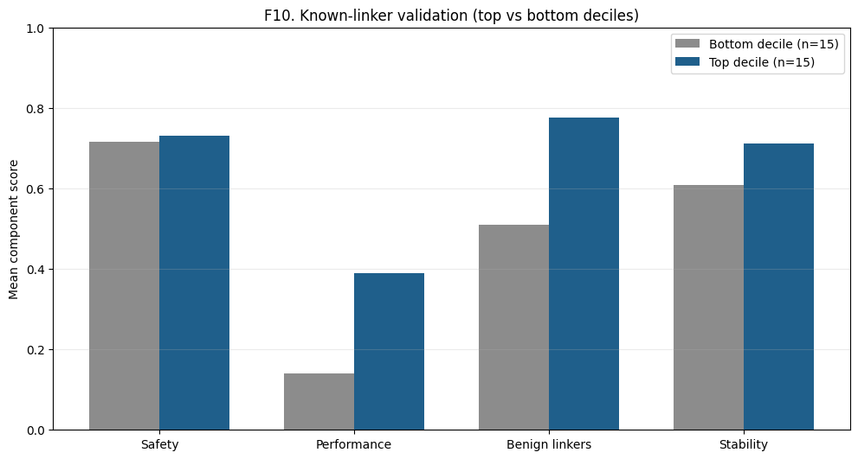
Figure F10. Known-linker validation: component contrast between top and bottom deciles of scored linkers. Mean total score was 0.547 for top decile comparing to bottom decile 0.352, indicating strong ranking separation. Largest component gap was observed in performance term (0.389 vs 0.141), followed by benign linkers term (0.776 vs 0.510).
Generalization limits. This reward is intentionally lightweight and linker-centric; it does not fully capture assembled-framework topology, explicit host-guest energetics, or payload-specific transport physics. Accuracy can be increased when the reward is customised to a selected payload molecule.
For payload-specific calibration, geometric accessibility should correlate to pore volume (PLD and LCD), ASA, and pore-size distribution relative to payload kinetic diameter (Pétuya (2022)). Loading affinity should incorporate adsorption free energy, electrostatic complementarity, hydrogen-bond donor/acceptor matching, and local polarity around anchoring motifs. Payload calibration could also include leakage control should include diffusion barrier proxies, release half-life targets, and burst-release penalties under physiological pH conditions.
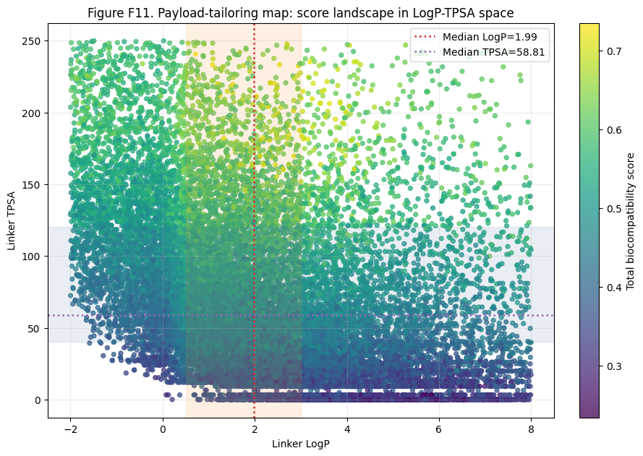
Figure F11 illustrates the current score landscape in LogP-TPSA space and highlights why payload-dependent windowing is necessary: the median point of the landscape is LogP = 1.986, TPSA = 58.81, with median total score 0.511, which aligns with a balanced polarity-hydrophobicity regime. The scores show a negative monotonic trend with LogP, indicating hydrophobic excess is generally penalized in this reward setup and a positive monotonic trend with TPSA, suggesting polarity-sensitive terms are highly influential.

References:
Yao, Z. et al. (2021) ‘Inverse design of nanoporous crystalline reticular materials with deep generative models’, Nature Machine Intelligence, 3(1), pp. 76–86. doi:10.1038/s42256-020-00271-1.
Wu, L. et al. (2022) ‘Toxric: A comprehensive database of toxicological data and benchmarks’, Nucleic Acids Research, 51(D1). doi:10.1093/nar/gkac1074.
Pétuya, R. et al. (2022) ‘Machine‐learning prediction of metal–organic framework guest accessibility from linker and metal chemistry’, Angewandte Chemie International Edition, 61(9). doi:10.1002/anie.202114573.
Menon, D. and Fairen-Jimenez, D. (2025) ‘Guiding the rational design of biocompatible metal-organic frameworks for Drug Delivery’, Matter, 8(3), p. 101958. doi:10.1016/j.matt.2025.101958.

